BRAC University
Department of Computer Science and Engineering

Summer – 2007
CSE110 (Programming Language-I )
Lab 8

1.Write a Java program that will calculate the value of y if the expression of y is as follows (n is the input):

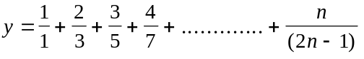

2. Write a Java program that will calculate the value of y if the expression of y is as follows (n is the input):

3. Suppose the following expressions are used to calculate the values of L for different values of S:

L = 
L = 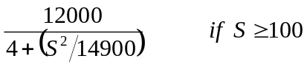

Write a Java program that reads a value of S and then calculates the value of L.

4. Write Java program that takes an integer from the user and extracts and displays each digit of the integer in English. So, if the user types in 932, the program will display nine three two

Home Work:

Write a Java program that performs four functions of a calculator. The program should request the user to enter a floating-point number, an operator and another floating-point number. It should then carry out the specified arithmetical operation: adding, subtracting, multiplying, or dividing the two floating-point numbers. Finally, it should display the result.

